Cloud Infrastructure Cost And
Resource Allocation Hub

Name: Abenanthan P Roll No: 240701005

Project Overview & Objectives

Introduction:
In modern software engineering, development teams frequently provision cloud virtual machines, databases, and storage buckets across providers (AWS, GCP, Azure) for testing and staging environments. However, developers often forget to terminate or downsize these instances once testing concludes. This leads to cloud sprawl and significant financial waste due to unmonitored idle infrastructure.

The Cloud Infrastructure Cost & Resource Allocation Hub is an enterprise-grade FinOps platform built on Zoho Creator. It manages the complete lifecycle of cloud resources, enforces department-level budget controls, automates idle asset detection, routes multi-level approval workflows, and triggers automated instance termination via REST APIs.

Objective:
The primary objective of this project is to build an enterprise-grade Cloud FinOps Engine using Zoho Creator. The platform:
- Manages the complete lifecycle of cloud assets.
- Enforces department-level budget limits before resources are provisioned.
- Routes resource requisitions through a multi-level approval pipeline.
- Automatically scans for underutilized assets via background tasks.
- Triggers real-time instance termination commands via REST API calls

System Architecture & Data Schema (5 Forms)

The application utilizes a relational database structure comprising 5 core forms:

Form 1: Departments Master

- Department Name: Single Line (AI/ML Team, DevOps, QA Testing, Backend Dev)
- Department Head: Single Line (Email)
- Overall Quarterly Budget ($): Currency / Decimal

Form 2: Cloud Projects Master

- Project Name: Single Line (NLP-Model-Training, Auth-Service-Dev)
- Department: Lookup field to Departments Master
- Lead Engineer: Single Line (Email)
- Cloud Provider: Dropdown (AWS, Google Cloud Platform (GCP), Microsoft Azure)
- Allocated Project Budget ($): Currency / Decimal
- Project Status: Dropdown (Active, Frozen / Over Budget)

Form 3: Cloud Resource Registry (Active Assets)

- Resource ID: Single Line (i-0a8bf29381, gcp-db-main-01)
- Project Name: Lookup field to Cloud Projects Master
- Resource Type: Dropdown (EC2 Compute Instance, RDS Database, S3 Storage Bucket, Kubernetes Cluster)
- Instance Size / Tier: Dropdown (t3.micro, t3.large, m5.2xlarge, db.r5.xlarge)
- Hourly Cost ($): Decimal (Auto-calculated via Deluge)
- Idle CPU Utilization (%): Decimal (Simulated metric, e.g., 2.5%)
- Resource Lifecycle Status: Dropdown (Running, Idle / Waste, Terminated)

Form 4: Cloud Resource Requisitions (Approval Gateway)

- Requisition ID: Auto-Number (REQ-5001)
- Project Name: Lookup field to Cloud Projects Master
- Requested By: Single Line (Developer Email)
- Requested Instance Tier: Dropdown (t3.micro, t3.large, m5.2xlarge)
- Justification: Multi-line Text
- Estimated Monthly Cost ($): Decimal (Auto-calculated)
- Approval Status: Dropdown (Pending Department Head, Approved, Rejected)

Form 5: Resource Cleanup Logs (Audit Trail)

- Log ID: Auto-Number (LOG-1001)
- Resource Name: Lookup field to Cloud Resource Registry
- Project Name: Single Line
- Wasted Dollars Saved ($): Decimal
- Action Taken: Dropdown (Auto-Stopped via API, Developer Notified, Manually Retained)
- Execution Timestamp: Date-Time

Workflow Implementations

Form Workflows (On User Input & On Validate):

1. Dynamic Hourly Cost Calculation (On User Input):
  - Trigger: Selecting an instance tier in Cloud Resource Requisitions or Cloud Resource Registry.
  - Logic: Automatically maps instance size to hourly pricing ($0.0104/hr for t3.micro, $0.3840/hr for m5.2xlarge) and computes projected monthly costs.

2. Budget Pre-Validation (On Validate):
  - Trigger: Submitting a new resource requisition.
  - Logic: Compares projected instance costs against the project's remaining budget. Blocks submission if the request breaches the allocated limit.

Multi-Level Approval Workflow

Trigger: Submission of a new request in Cloud Resource Requisitions.
Execution Flow:
- Notification and task routing sent to the Department Head configured in Departments Master.

- If Rejected: Status updates to Rejected, and notification email with reviewer comments is sent to the developer.

- If Approved: Status updates to Approved, triggering a Deluge On Approval script to automatically provision an active record in Cloud Resource Registry.

Schedule Workflow (Scheduled Task)
Trigger: Deluge Scheduled Task running every Friday at 8:00 PM.
Execution Flow:
- Scans Cloud Resource Registry for running resources with average CPU utilization below 5.0%.

- Automatically updates asset status to Idle / Waste.

- Calculates total wasted dollars and logs an audit entry in Resource Cleanup Logs.

- Dispatches an alert email to the project lead.

REST API Integration Architecture:

To demonstrate external infrastructure management without needing expensive live cloud subscriptions, the application implements an outbound REST API connection using Zoho Creator's native invokeUrl task.

Integration Concept & Workflow:

- User Action: The FinOps Administrator clicks a custom action button titled "Stop Idle Instance" on any flagged resource record in the system.

- Payload Construction: The system extracts the active record's metadata—specifically Resource_ID, Cloud_Provider, and target action status (STOP_INSTANCE).

- Outbound Dispatch: The system packages this metadata into a structured JSON payload and dispatches an HTTP POST request to an external API endpoint/webhook.

- API Endpoint Verification: An external listener (e.g., Webhook.site or Postman Mock Gateway) receives and parses the payload in real-time, verifying that the termination command was received.

- State Synchronization: Upon receiving a successful HTTP response (200 OK), the application automatically updates the instance status in the Cloud Resource Registry from Running to Terminated.

Sample Deluge Script:

// Execute API Call
response = invokeurl [
url: "https://webhook.site/YOUR-UNIQUE-WEBHOOK-ID"
type: POST
headers: {"Content-Type": "application/json", "Authorization": "Bearer FINOPS_SECRET_TOKEN"}
string: {
"instance_id": input.Resource_ID,
"action": "STOP_INSTANCE",
"cloud_provider": input.Project_Name.Cloud_Provider,
"requested_by": zoho.adminuser
}.toString()
];

input.Resource_Lifecycle_Status = "Terminated";
alert "Instance " + input.Resource_ID + " successfully stopped.";
Analytical Dashboard Layout (Page Builder)

The executive FinOps dashboard is built using Zoho Creator Page Builder and includes:
- 3 KPI Cards:
  - Total Monthly Spend
  - Total Cloud Waste
  - Total Active Instances
- Pie Chart: Cost Allocation by Department (AI/ML vs DevOps vs QA).
- Bar Chart: Top 5 Most Expensive Cloud Projects.
- Real-time Report Grid: Filtered view displaying resources tagged as Idle / Waste pending administrative action.

Workflow / Form Relationship Diagram

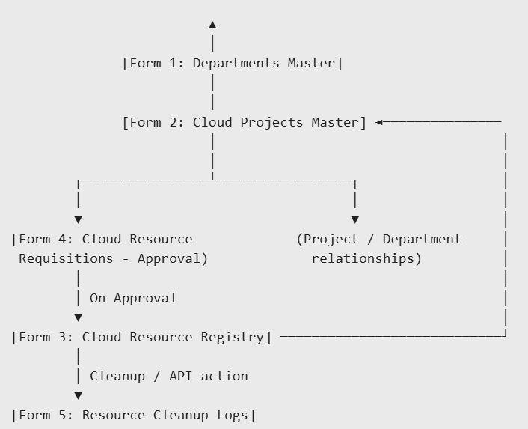
Summary And Conclusion:
The Cloud Infrastructure Cost & Resource Allocation Hub (FinOps Engine) demonstrates how low-code development platforms like Zoho Creator can effectively solve complex software engineering and cloud management problems. By combining normalized data modeling, multi-level approval workflows, scheduled automated auditing, and outbound REST API orchestration (invokeUrl), the project delivers a complete enterprise FinOps solution.

Component | Technical Implementation
Platform | Zoho Creator (Free Student / Trial Account)
Backend Language | Deluge Scripting Language
Relational Forms | 5 Forms (Departments, Projects, Registry, Requisitions, Logs)
Workflows | Form Validation, Multi-Level Approval Engine, Scheduled Sweeper
API Integration | Outbound HTTP POST via invokeUrl to Webhook/Mock Server
User Interface | Page Builder Analytics Dashboard with KPI Widgets

